**ARC-GIS**

**EXCERCISE: 2**



**BY – AMANUEL LEGESSE SOFTWARE ENG. EXT**

**ID – ATE/3628/11**

**Creating a point dataset**

* 1. 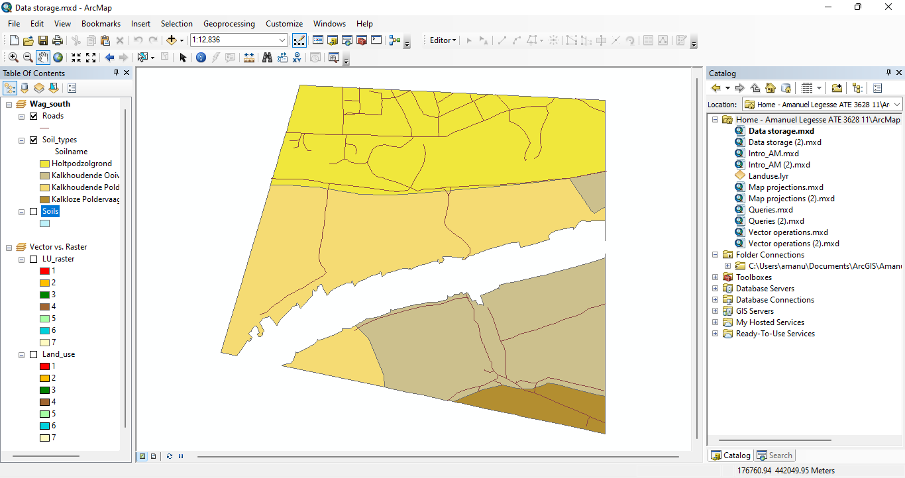:

**1.A**:

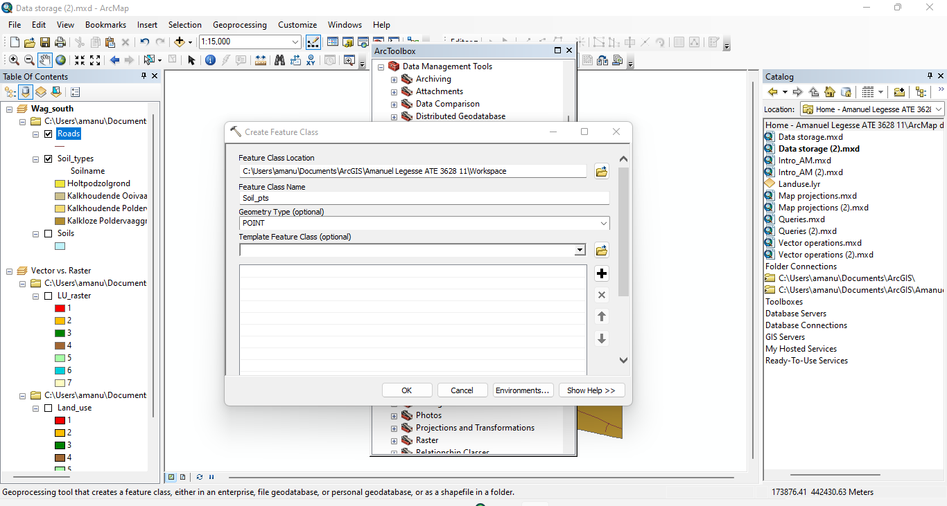

**1.B:**

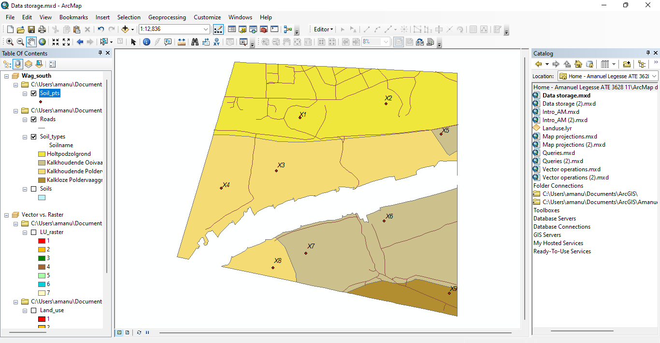

**1.C:**  The attribute table of dataset ‘Soil_pts’ contains 9 records.

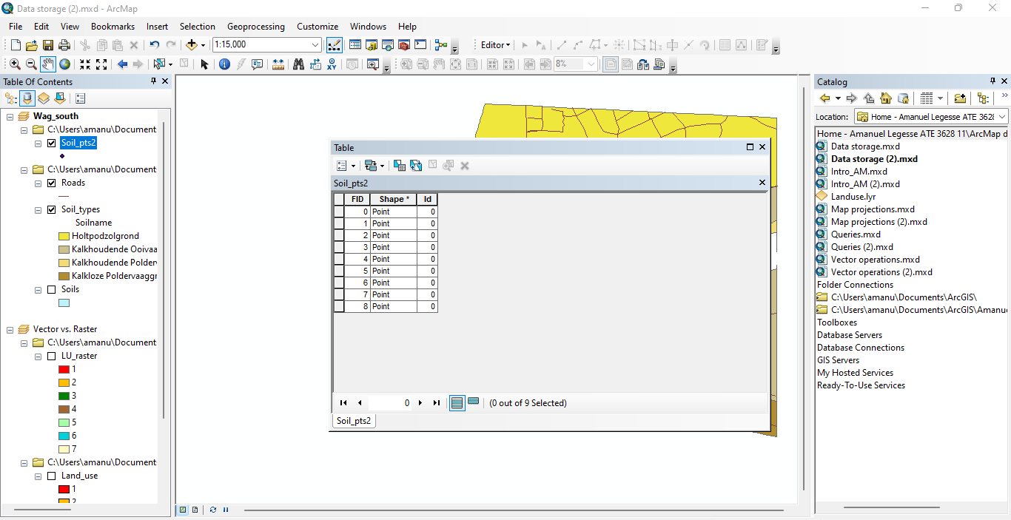

**Adding attributes to point features**

**2.A**

**FLOAT** — Numeric values with fractional values within a specific range

**Integer -** Numeric values without fractional values within specific range

The **TEXT data** type stores any kind of text data. It can contain both single-byte and multi byte characters that the locale supports.

The date data type **can store dates, times, or dates and times**. The default format in which the information is presented is mm/dd/yyyy hh:mm:ss and a specification of AM or PM.

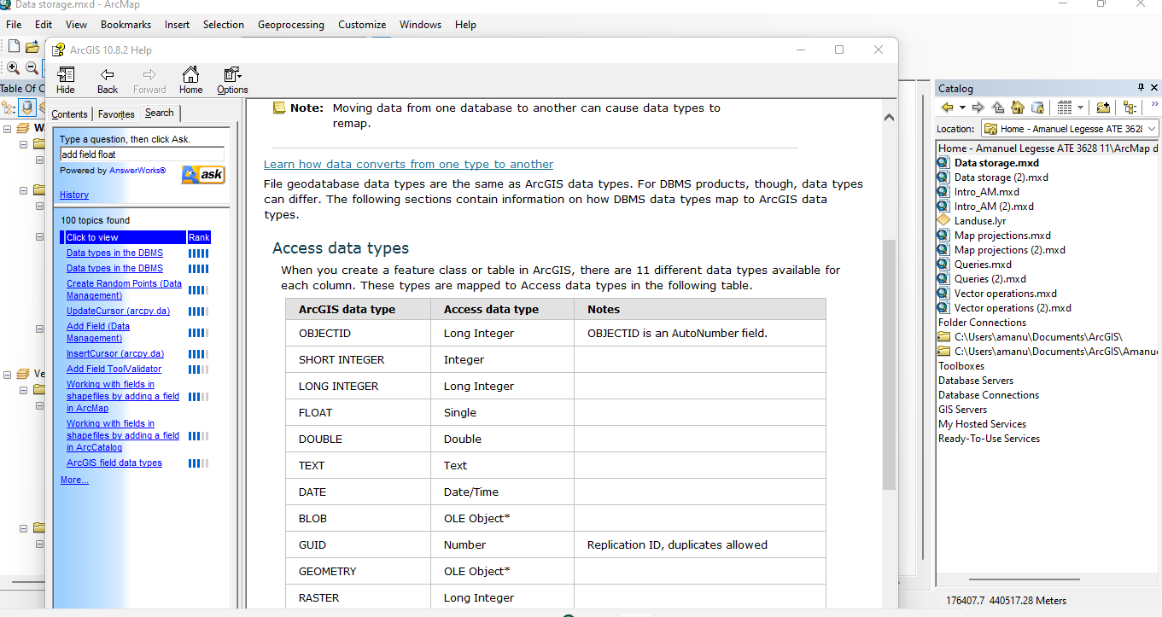

**2.B:**

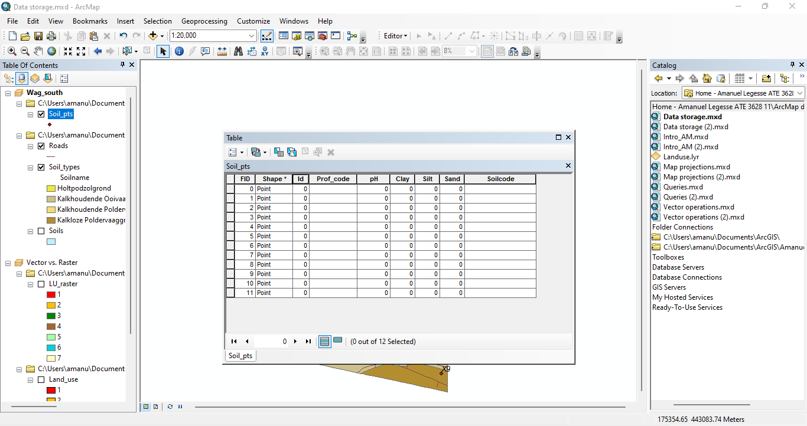

**2.C:**

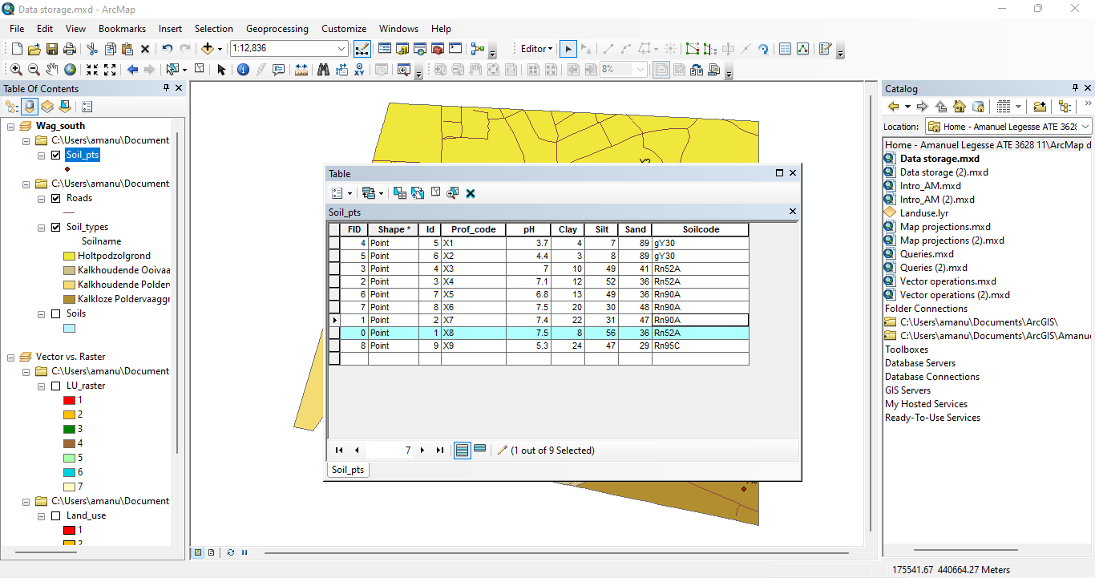

**Calculating the area of polygon features**

**3.A:**

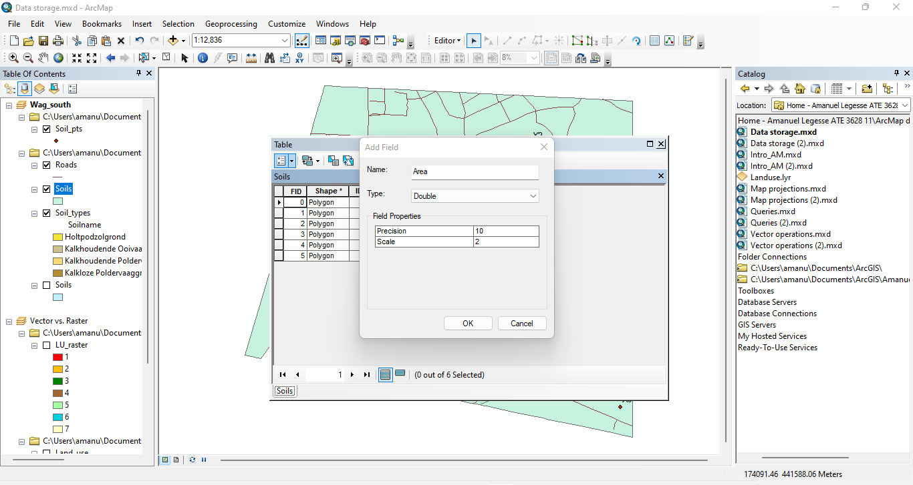

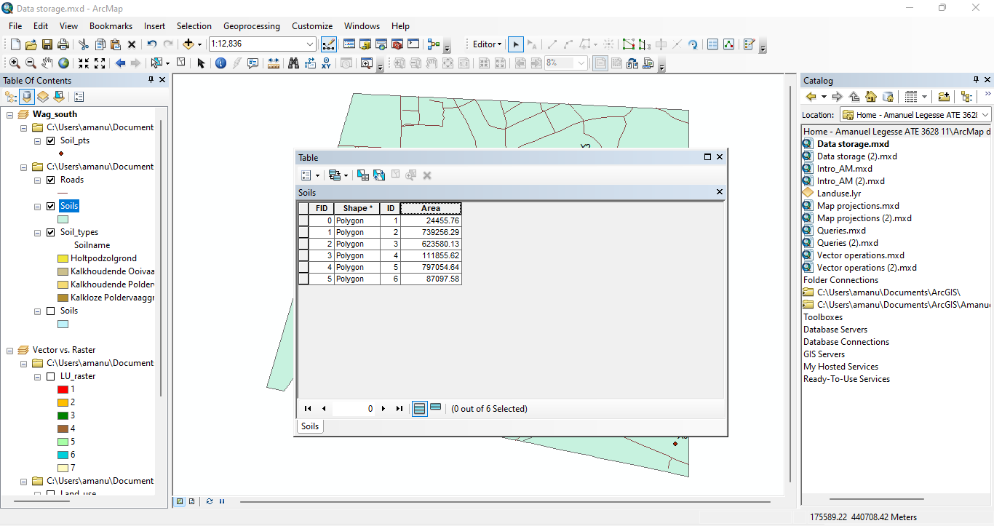

**Creating a new table**

**4.A:**

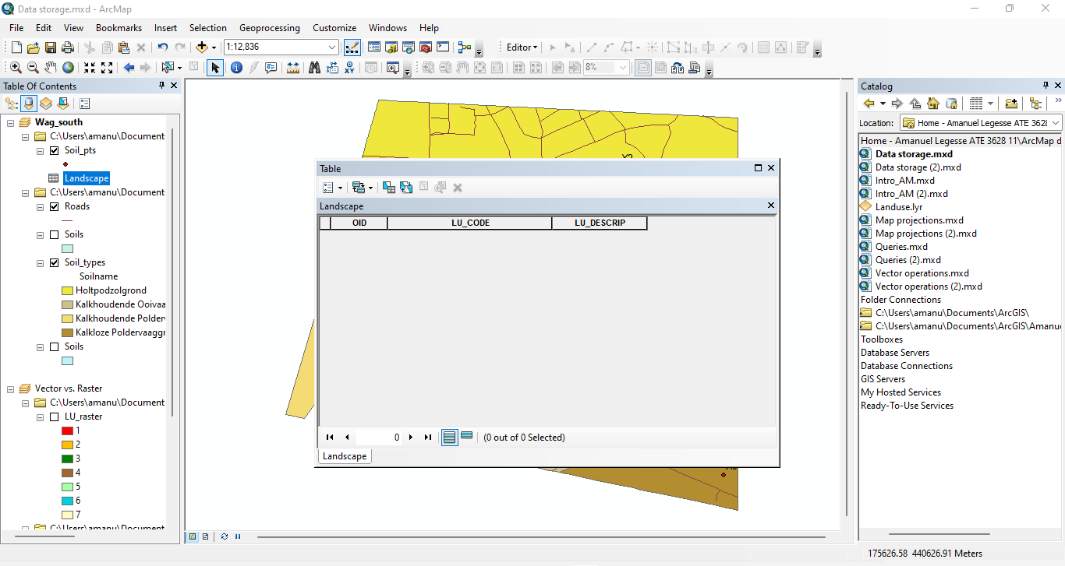

**4.B:**

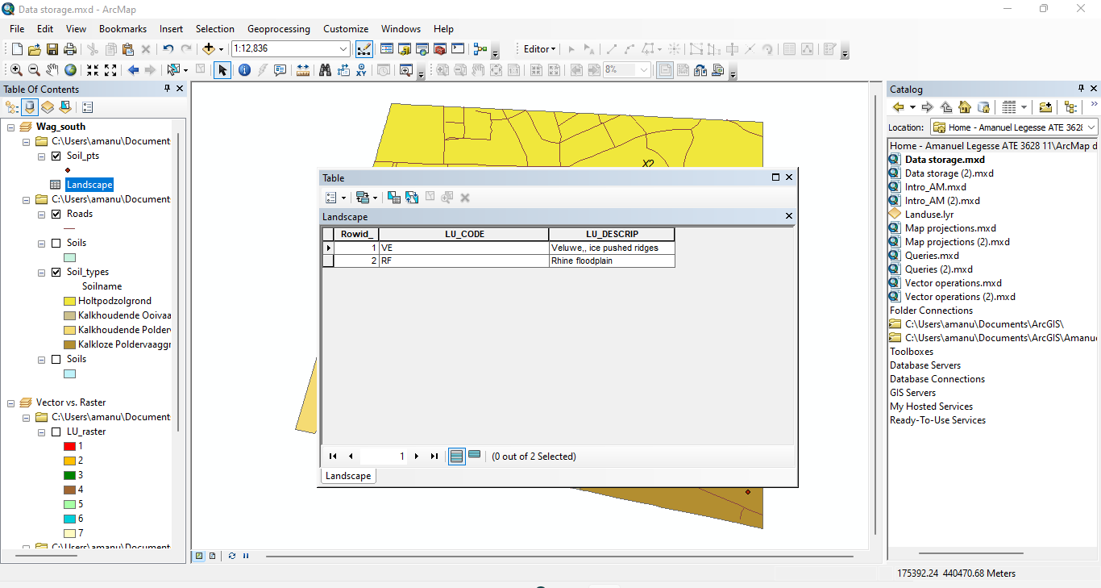

**Joining tables**

**5.A:**

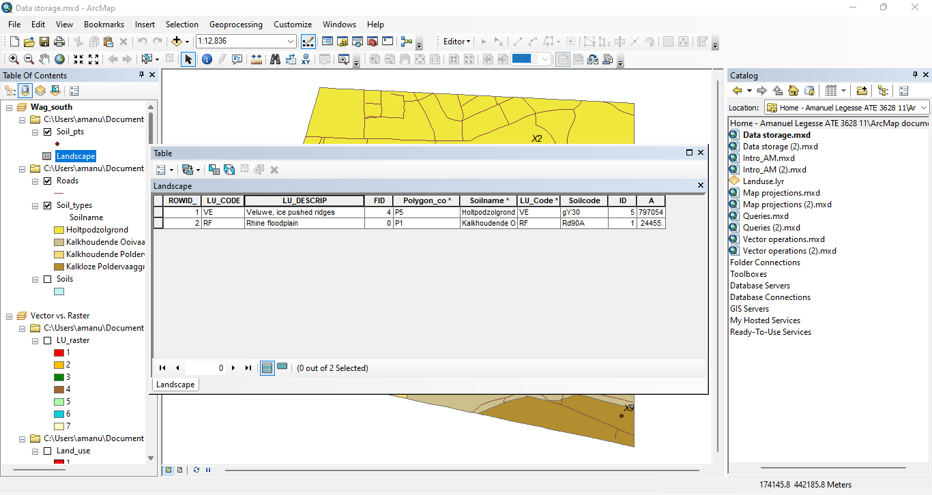

**5.B**

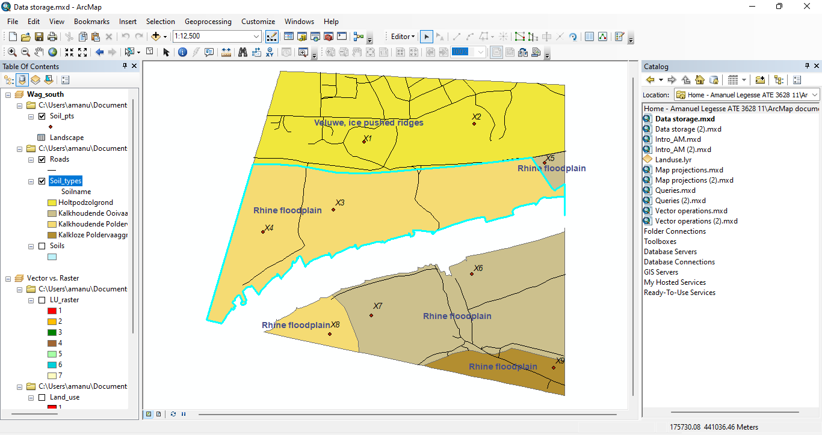

**Data structure of a raster dataset**

**6.A:** The raster attributes of ‘LU_raster’ are create out integer having an associated raster cell value attribute table.

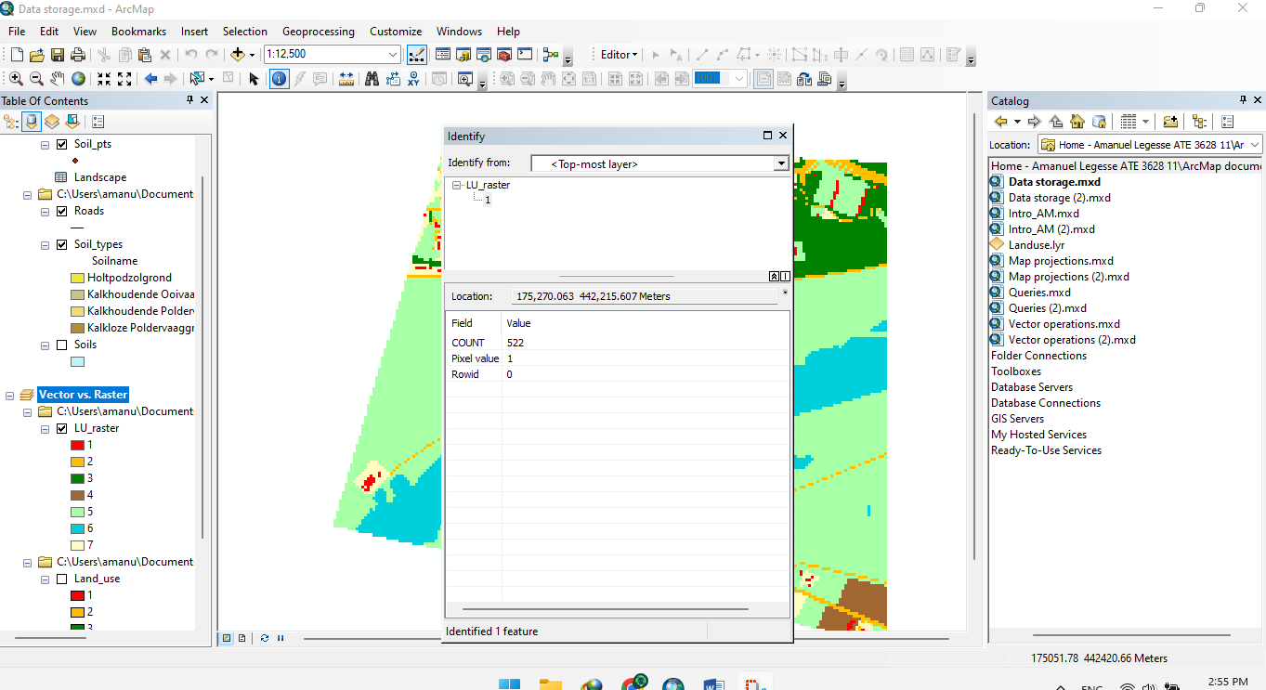

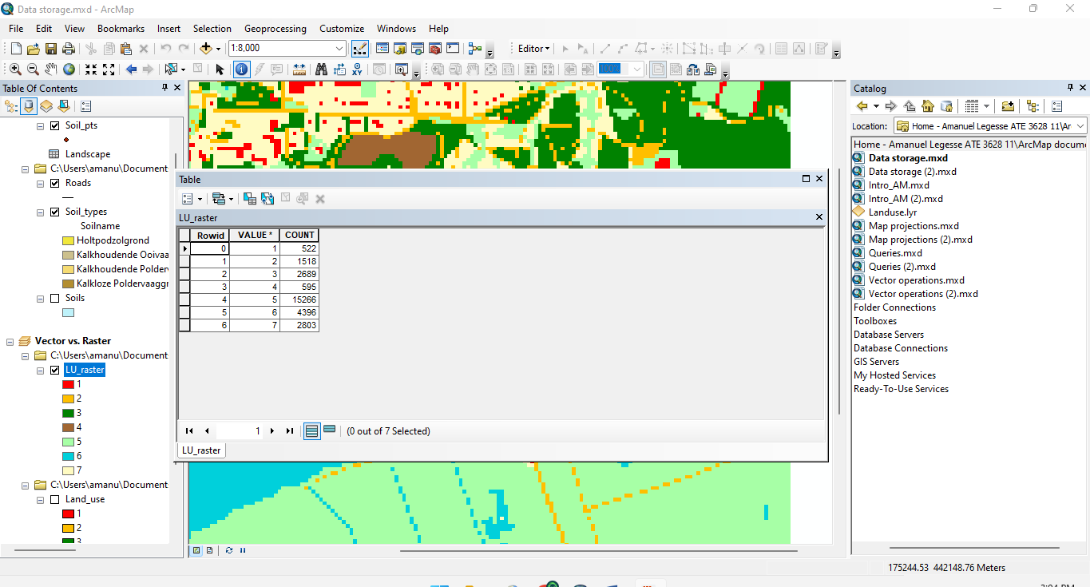

**6.B**: ’ LU_raster’ is a discrete geographic features that have definable boundaries because it features lakes, lands, buildings, roads…

**6.C:** the attribute table of ‘LU_raster’ contains 7 values

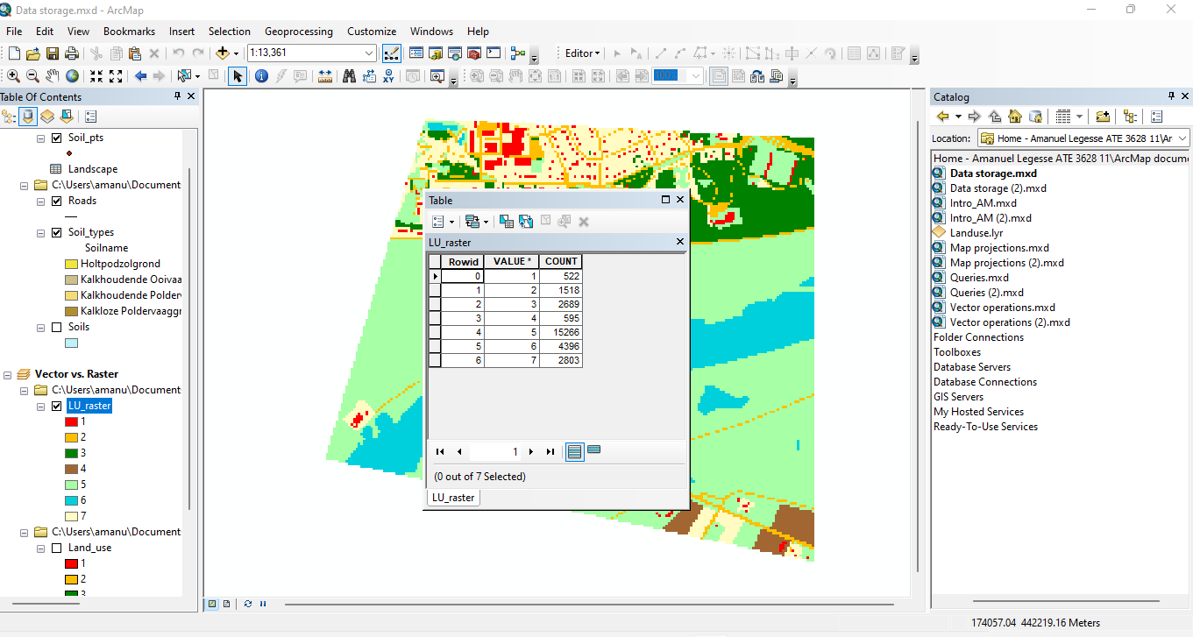

**Zone vs. region in raster**

**7.** Zones because it represent all geographic objects with the same value and in the attribute table the values represent the zones.

**8.**

Lans_Use is a type of attribute with fields specifying the area, perimeter and shape of the land mainly focusing on just the lands where Land_raster specifies the values and counts of that raster.

